Please note that I mixed the 2 questions into 1 project. (I added the textures and then moved the rectangles with the textures)

1st Run: Static Rectangles with Texture

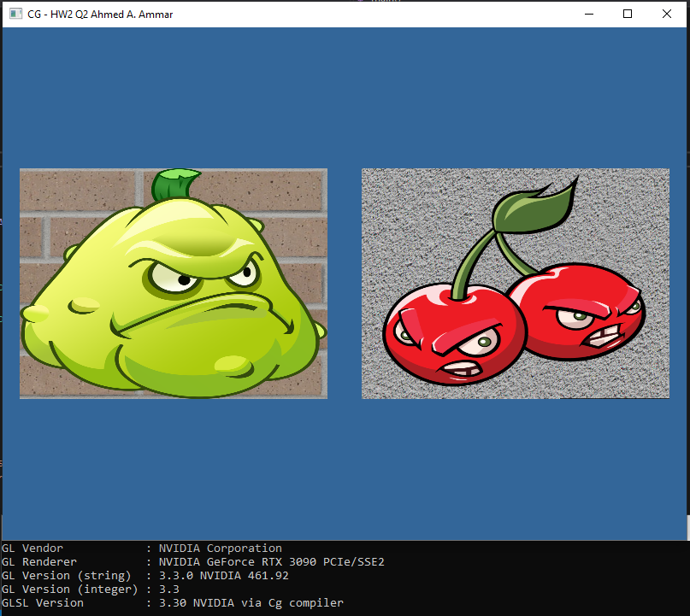

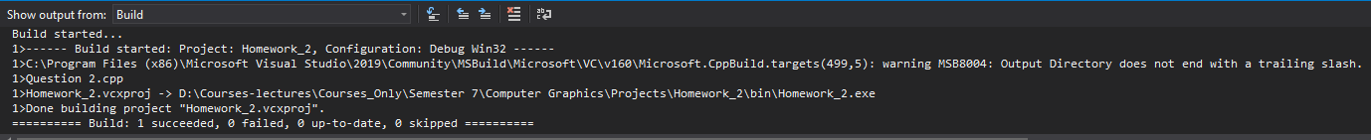

2nd Run: Moving Rectangles with Textures



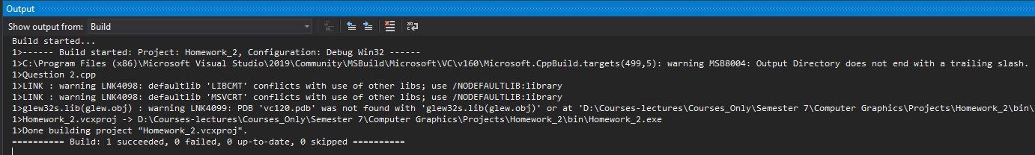

Pictures Citation:

1. plant.png: <https://www.pngitem.com/middle/iibbm_plants-vs-zombies-png-image-plants-vs-zombies/>
2. cherrybomb.png: <https://www.pngwing.com/en/free-png-detwg>